Docker Task-3
Create a image from running container.
- Run a container
docker run -it ubuntu bash
Install something inside:
apt update
apt install nginx -y
Exit:
Exit
- Check container ID
docker ps -a
- Create image from container
docker commit <container_id> my-nginx-image
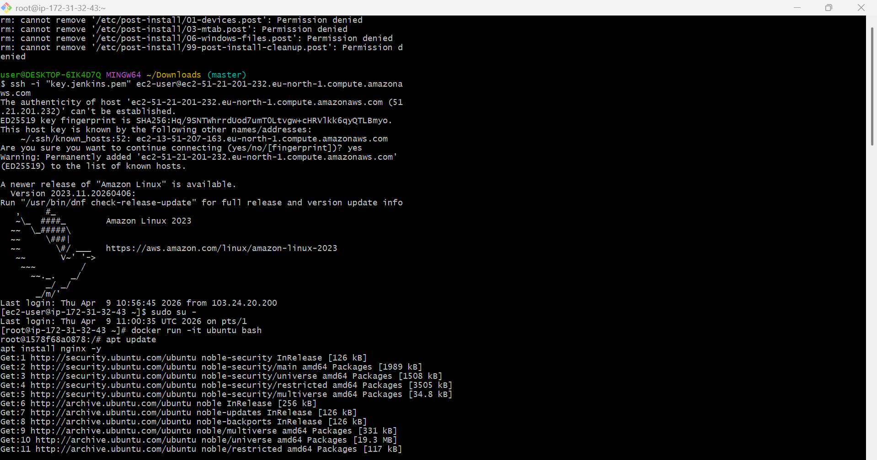
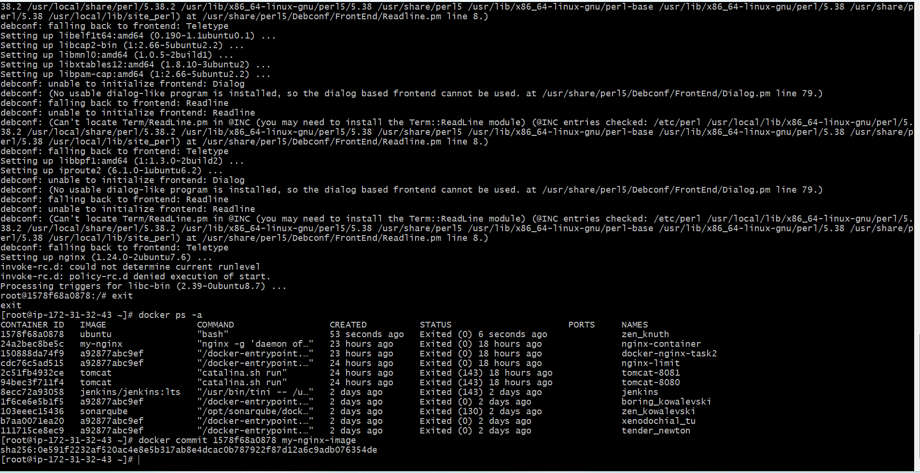
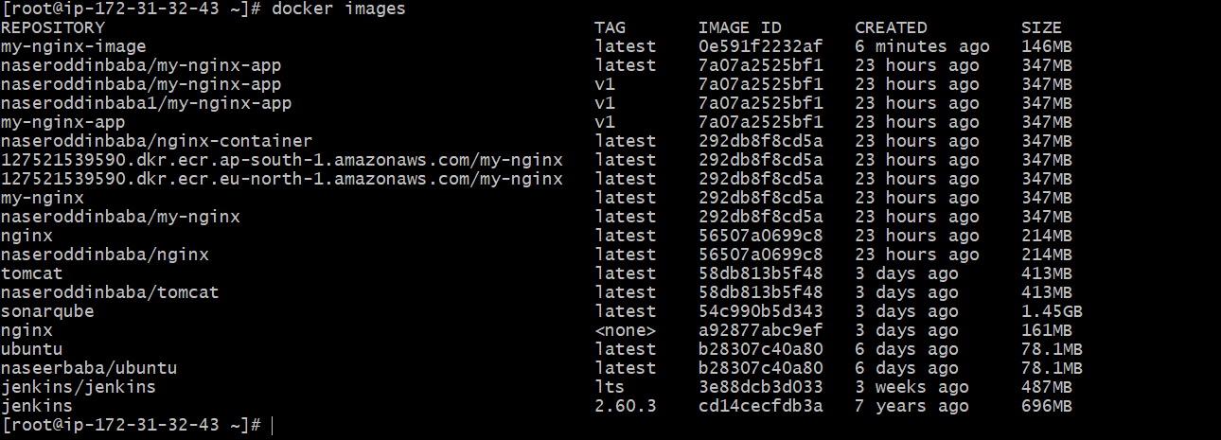
Copy image from local machine to docker server and load the image.
- Save image
docker save -o myimage.tar my-nginx-image
- Copy to /tmp
Run from your local:
scp -i /c/Users/vigne/Downloads/docker.pem myimage.tar ec2-user@51.21.201.232:/tmp/
- Login to EC2
ssh -i /c/Users/vigne/Downloads/docker.pem ec2-user@51.21.201.232
- Verify File
ls /tmp

You should see: myimage.tar
- Load Docker Image
docker load -i /tmp/myimage.tar
- Verify Image
docker images
- Run Container
docker run -d -p 8080:80 nginx
- Check Running Container
docker ps
- Access Application
Open browser:
http:// 51.21.201.232:8080
Nginx welcome page will appear

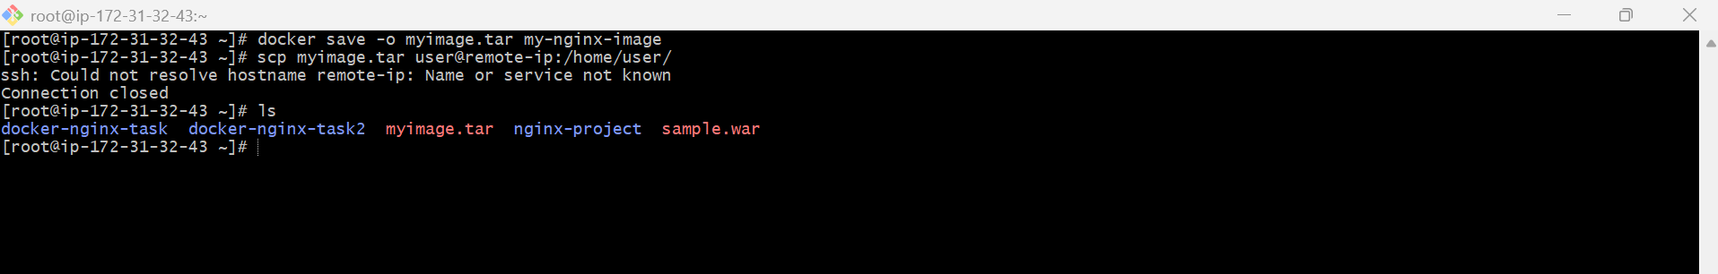
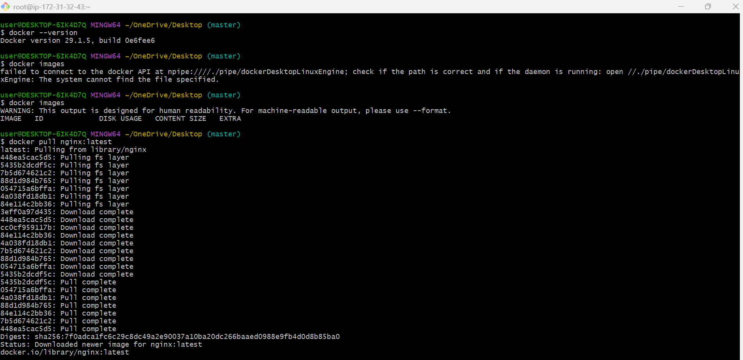
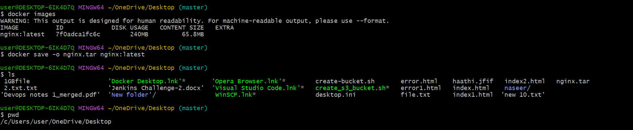
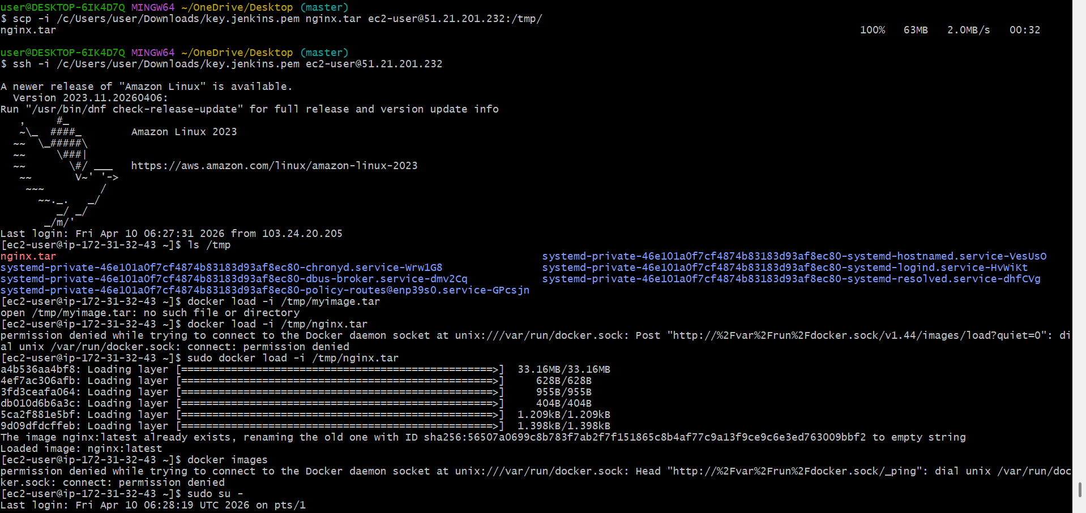
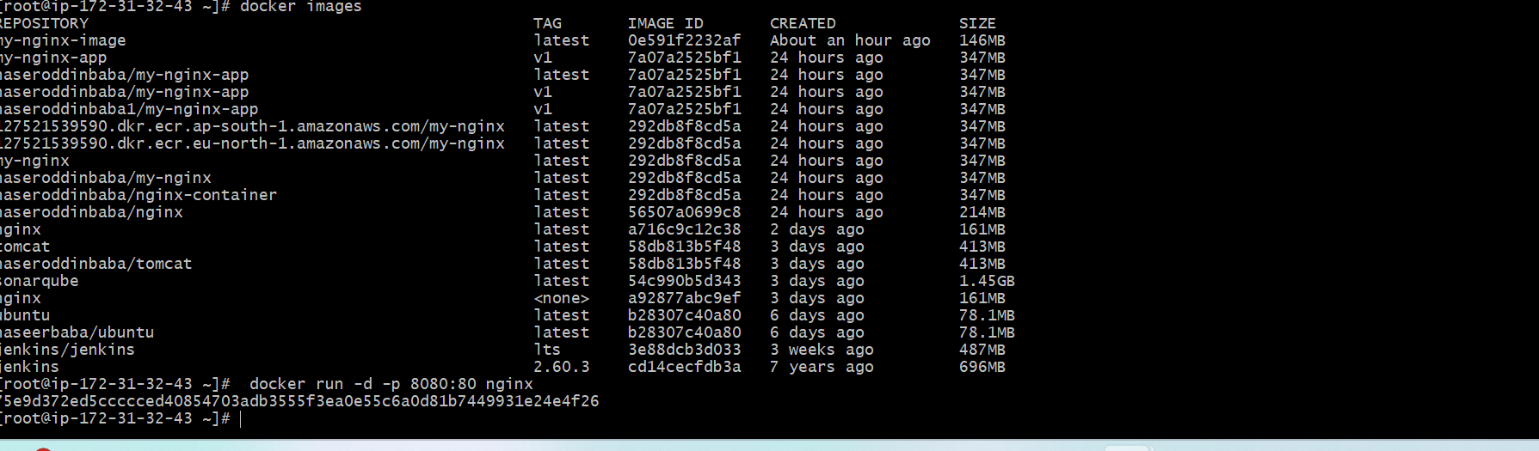

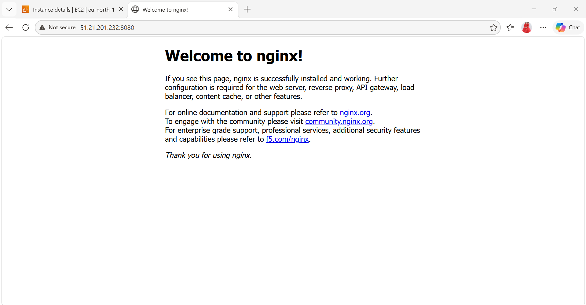
Create Docker image using alpine and customize with tomcat.
- Create Project Folder
mkdir tomcat-alpine
cd tomcat-alpine
- Create Dockerfile
vi Dockerfile
Paste this:
FROM alpine:latest
LABEL maintainer="naseerbaba"
RUN apk update && \
apk add openjdk8 wget tar && \
wget https://archive.apache.org/dist/tomcat/tomcat-9/v9.0.65/bin/apache-tomcat-9.0.65.tar.gz && \
tar -xvf apache-tomcat-9.0.65.tar.gz && \
mv apache-tomcat-9.0.65 /tomcat
EXPOSE 8080
CMD ["/tomcat/bin/catalina.sh", "run"]

- Build Docker Image
docker build -t tomcat-alpine .
-t = tag (image name)
Verify Image
docker images
- Run Container
docker run -d -p 8081:8080 tomcat-alpine
- Check Container
docker ps
- Access Tomcat
Open browser:
http://localhost:8080
You’ll see Tomcat page
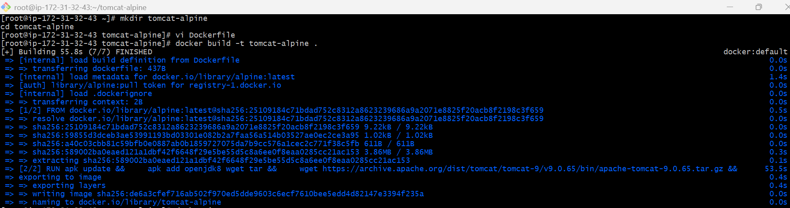
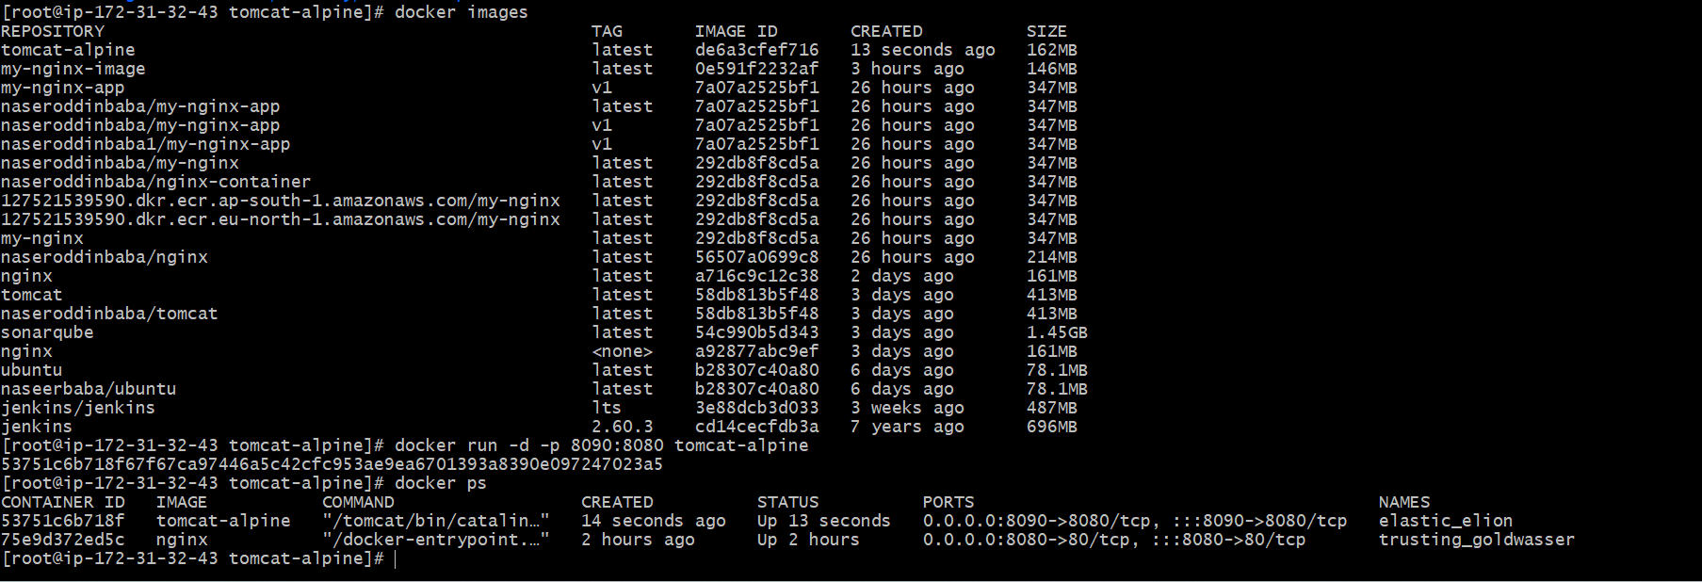

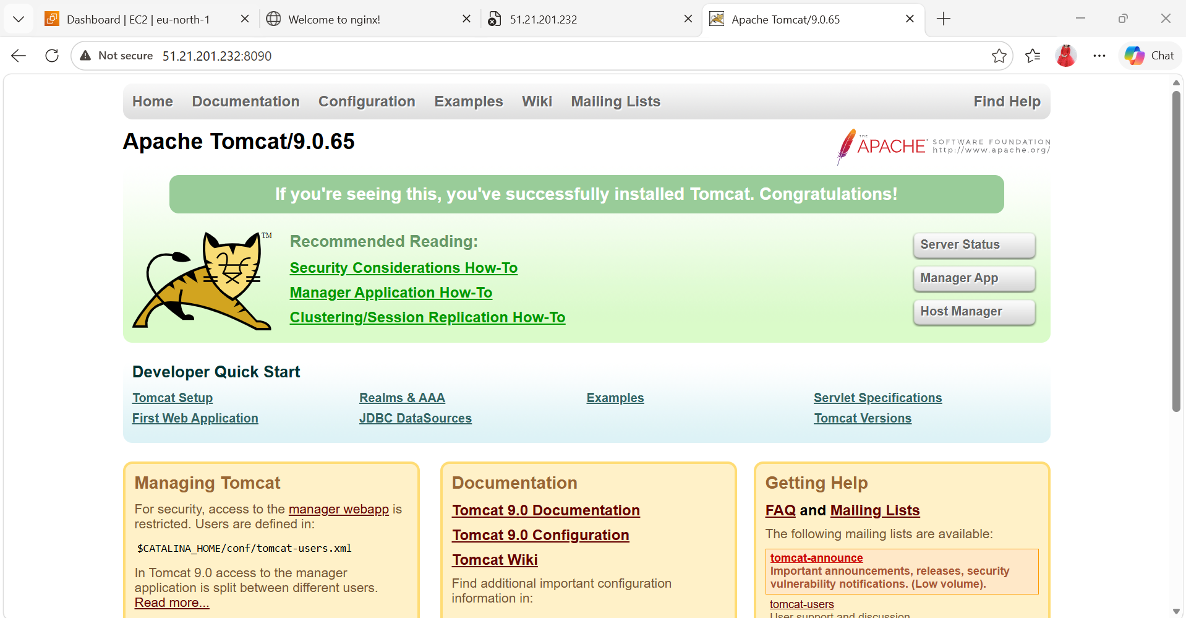
- Create single stage and multi stage docker file using this source code: https://github.com/betawins/multi-stage-example.git
- Clone the Repository
git clone https://github.com/betawins/multi-stage-example.git
cd multi-stage-example
- Create Dockerfile
vi Dockerfile
Paste this:
FROM maven:3.8.5-openjdk-17
WORKDIR /app
COPY . .
RUN mvn clean package
CMD "java", "-jar", "target/*.jar"
- Build Docker Image
docker build -t single-stage-app .
Output : BUILD SUCCESS
- Verify Image
docker images
- Run Container
docker run -d -p 8081:8080 single-stage-app
- Check Running Container
docker ps
- Access Application
Browse: http://localhost:8081
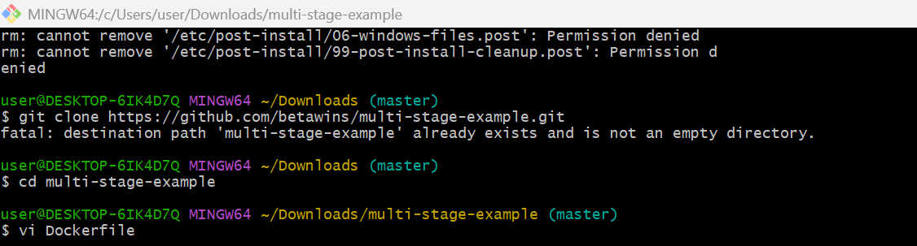

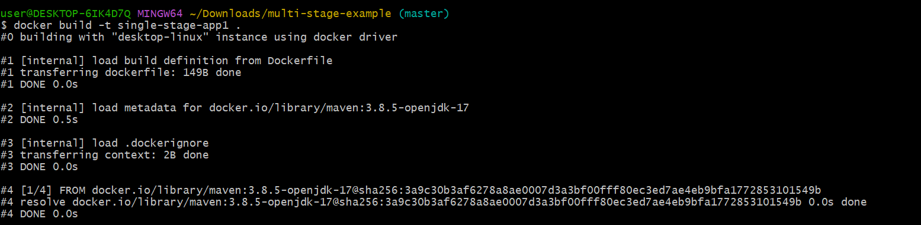
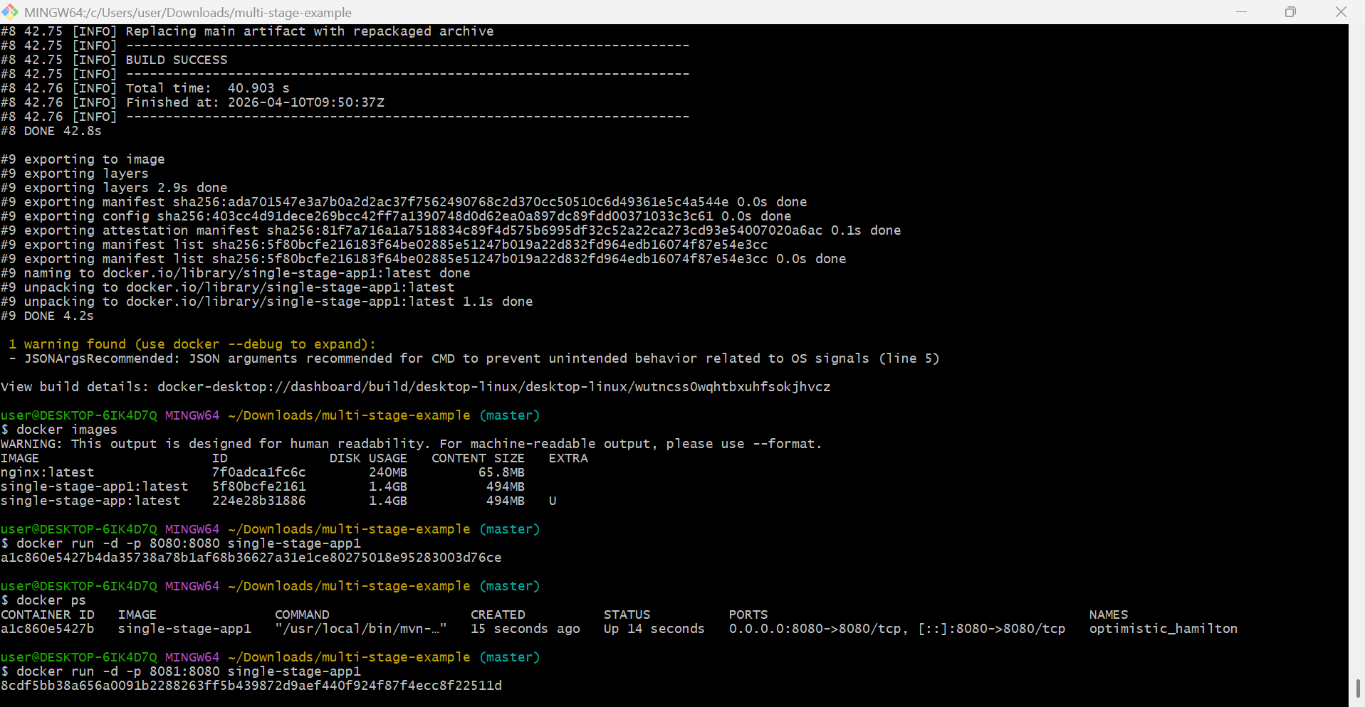
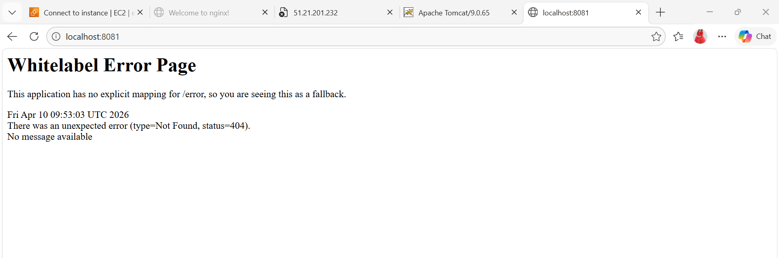
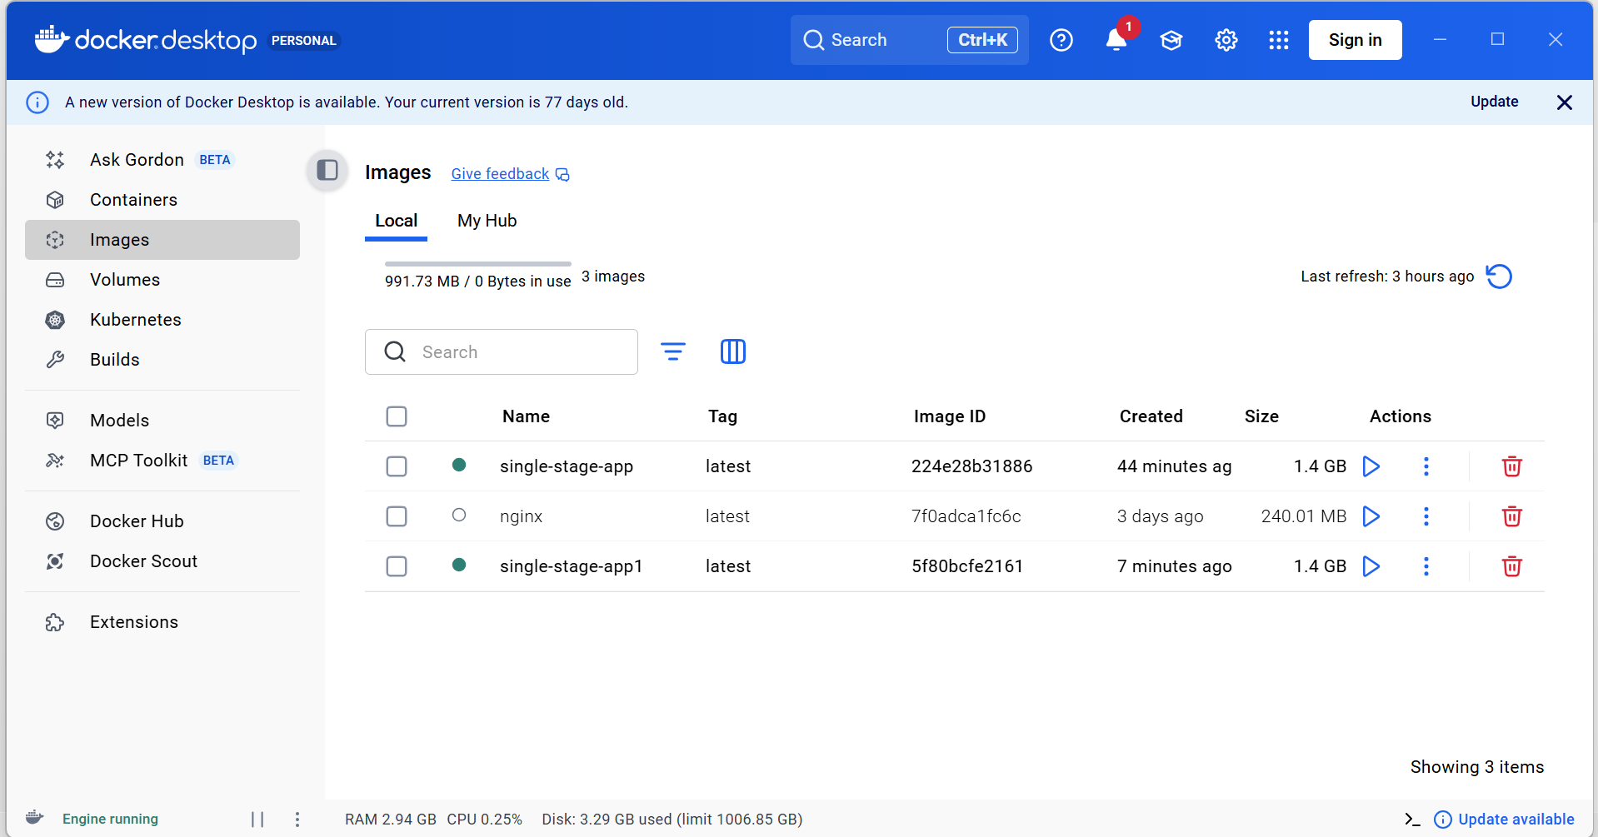
- Clone the Repository
git clone https://github.com/betawins/multi-stage-example.git
cd multi-stage-example
- Create Dockerfile
vi Dockerfile
Paste this:
# ---------- Stage 1: Build ----------
FROM maven:3.8.5-openjdk-17 AS build
WORKDIR /app
COPY . .
RUN mvn clean package -DskipTests
# ---------- Stage 2: Runtime ----------
FROM eclipse-temurin:17-jre
WORKDIR /app
COPY --from=build /app/target/*.jar app.jar
EXPOSE 8080
ENTRYPOINT ["java", "-jar", "app.jar"]
- Build Docker Image
docker build -t multi-stage-app .
Output : BUILD SUCCESS
- Verify Image
docker images
- Run Container
docker run -d -p 8084:8080 multi-stage-app
- Check Running Container
docker ps
- Access Application
browse: http://localhost:8084
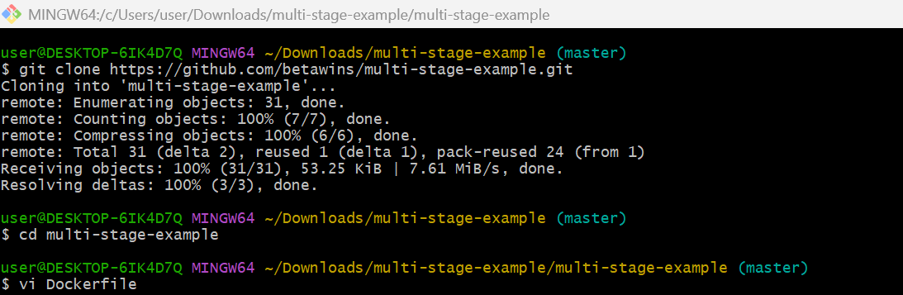
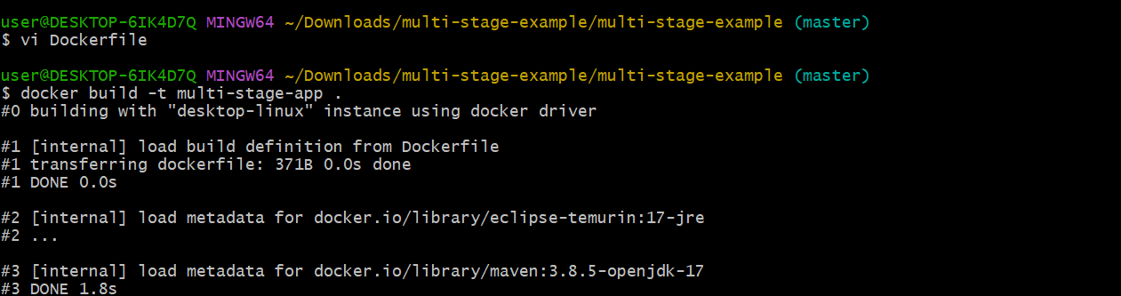
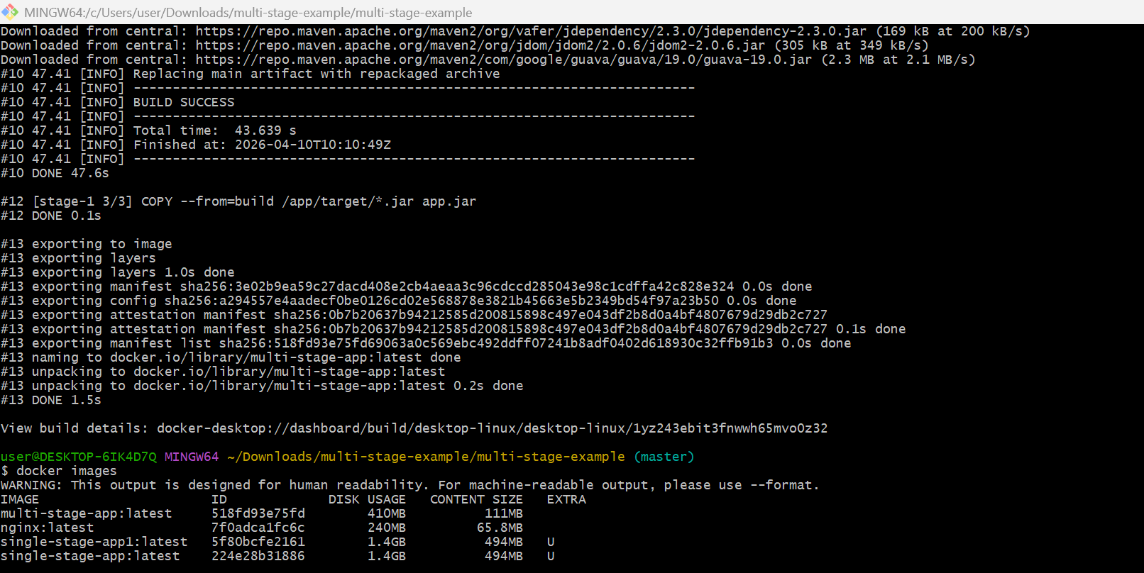

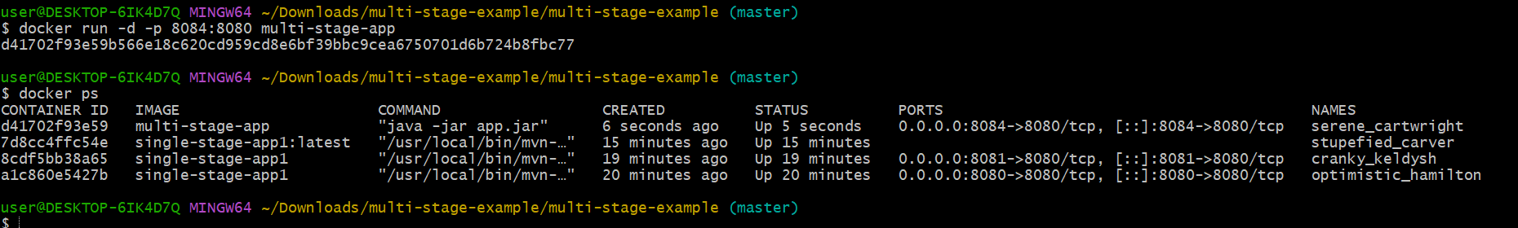
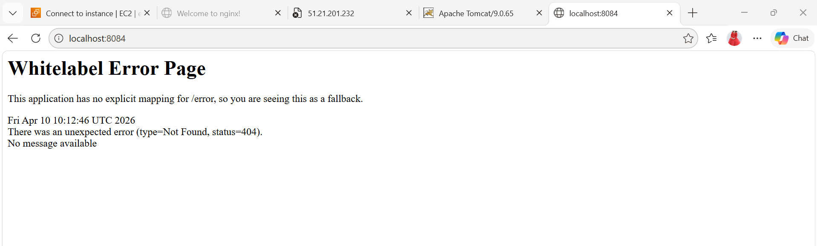
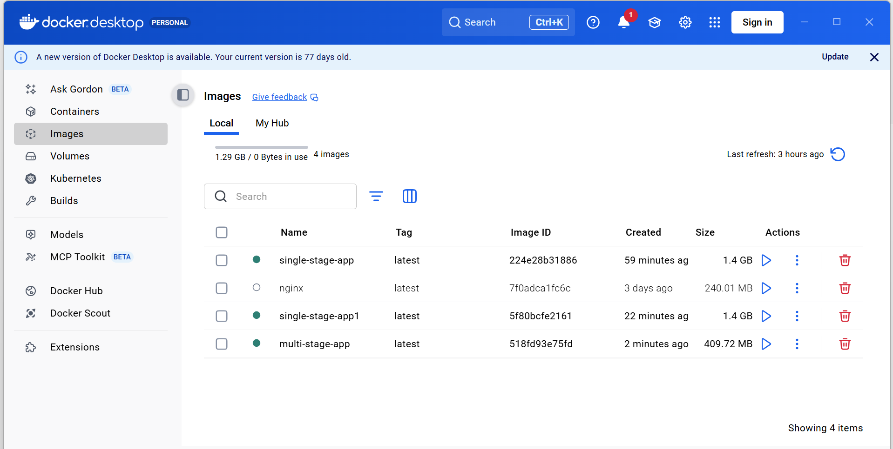
- Install docker compose and execute sample application.
- Install Docker Compose
On Amazon Linux / Linux
sudo curl -L "https://github.com/docker/compose/releases/latest/download/docker-compose-$(uname -s)-$(uname -m)" -o /usr/local/bin/docker-compose
- Give permission
sudo chmod +x /usr/local/bin/docker-compose
- Verify installation
docker-compose –version
- Create Project Folder
mkdir compose-app
cd compose-app
- Create docker-compose.yml
vi docker-compose.yml
Paste this sample app (Nginx)
version: '3'
services:
web:
image: nginx
ports:
- "8086:80"
- Run Application
docker-compose up -d
- Verify
docker ps
- Access App
Open browser: http://51.21.201.232:8086
Nginx welcome page
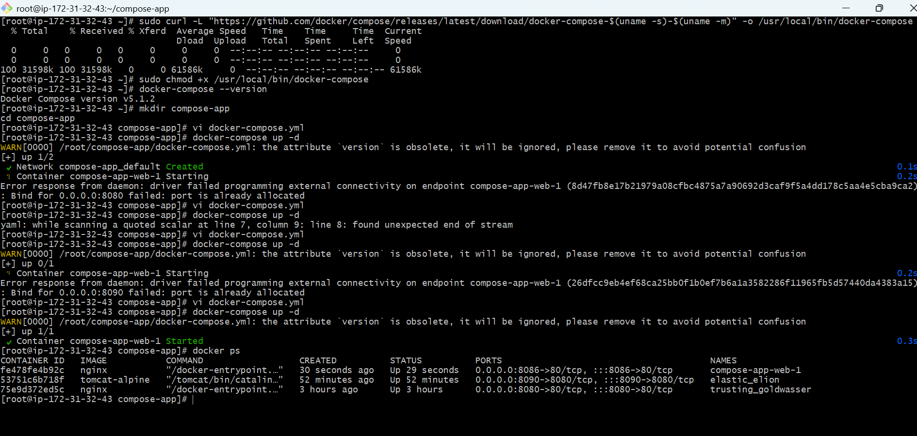
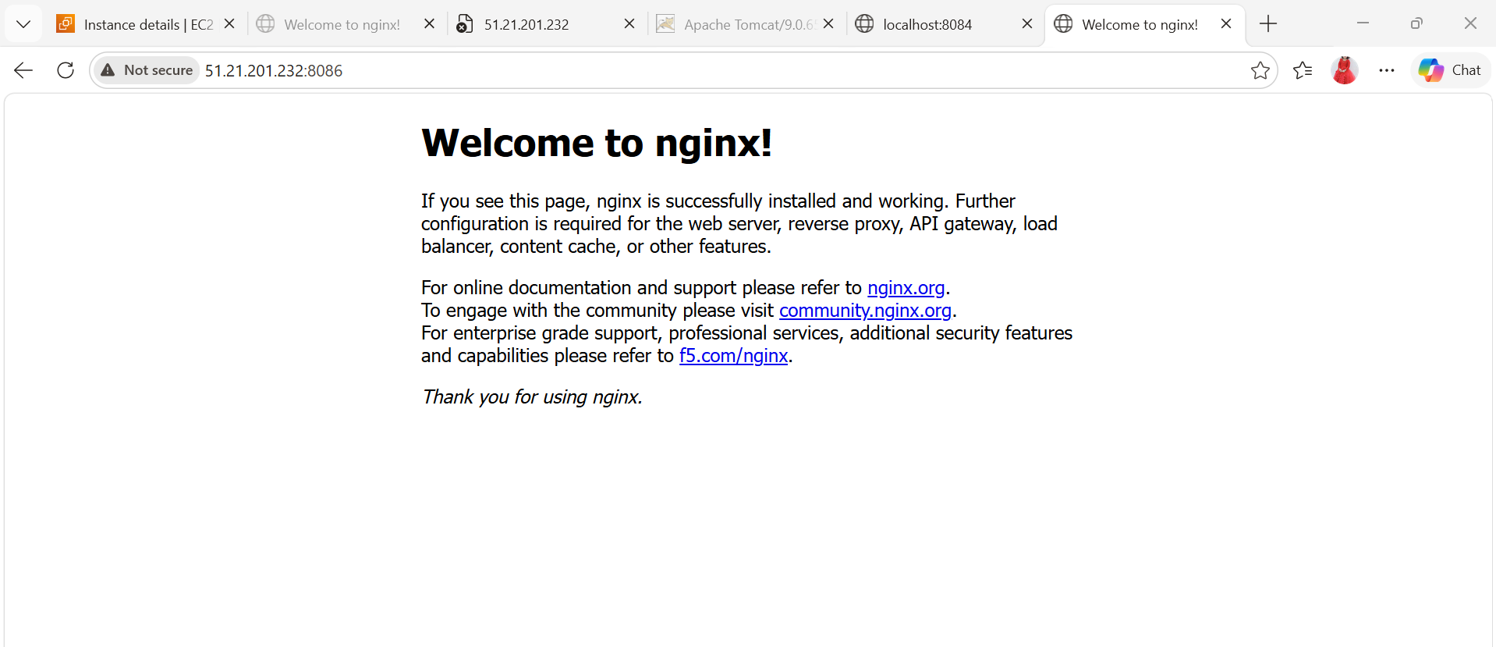

- Implement solution to scan images when pushed to docker registry.
- Install Trivy (Correct Way)
sudo yum install -y wget
wget https://raw.githubusercontent.com/aquasecurity/trivy/main/contrib/install.sh
sudo sh install.sh -b /usr/local/bin
- Verify Installation
trivy --version
- Scan Docker Image
trivy image nginx
What You’ll See
CRITICAL vulnerabilities
HIGH / MEDIUM / LOW
- Use in DevOps Pipeline
trivy image nginx --exit-code 1 --severity HIGH,CRITICAL
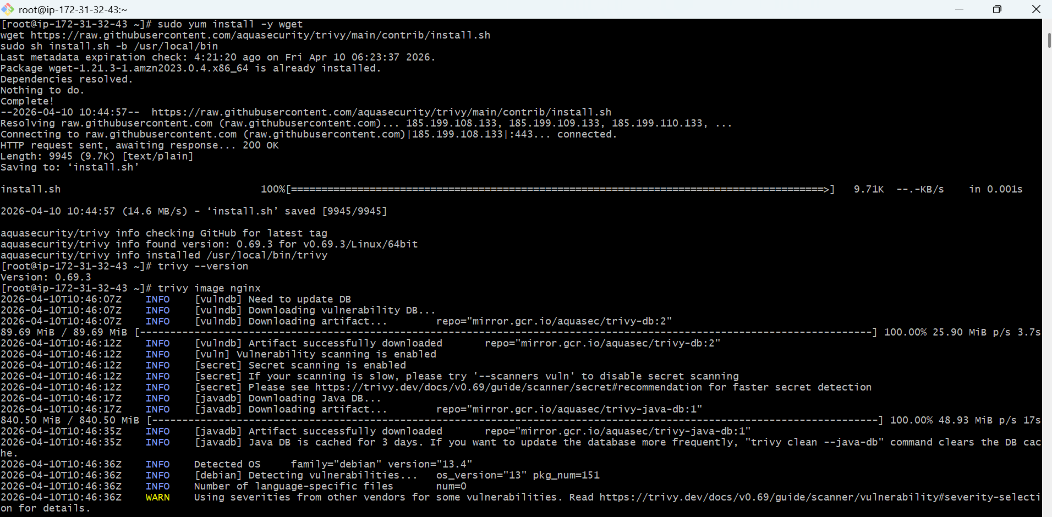

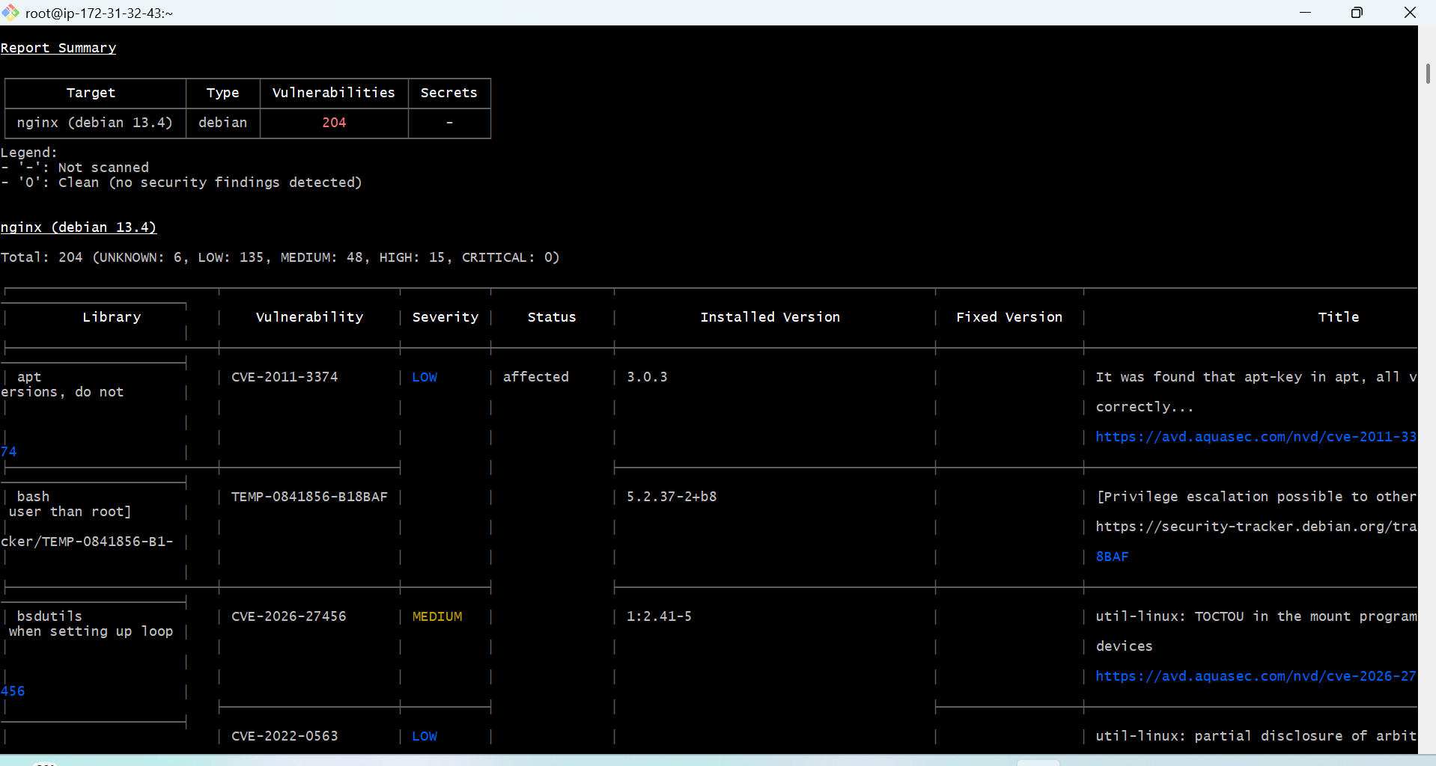

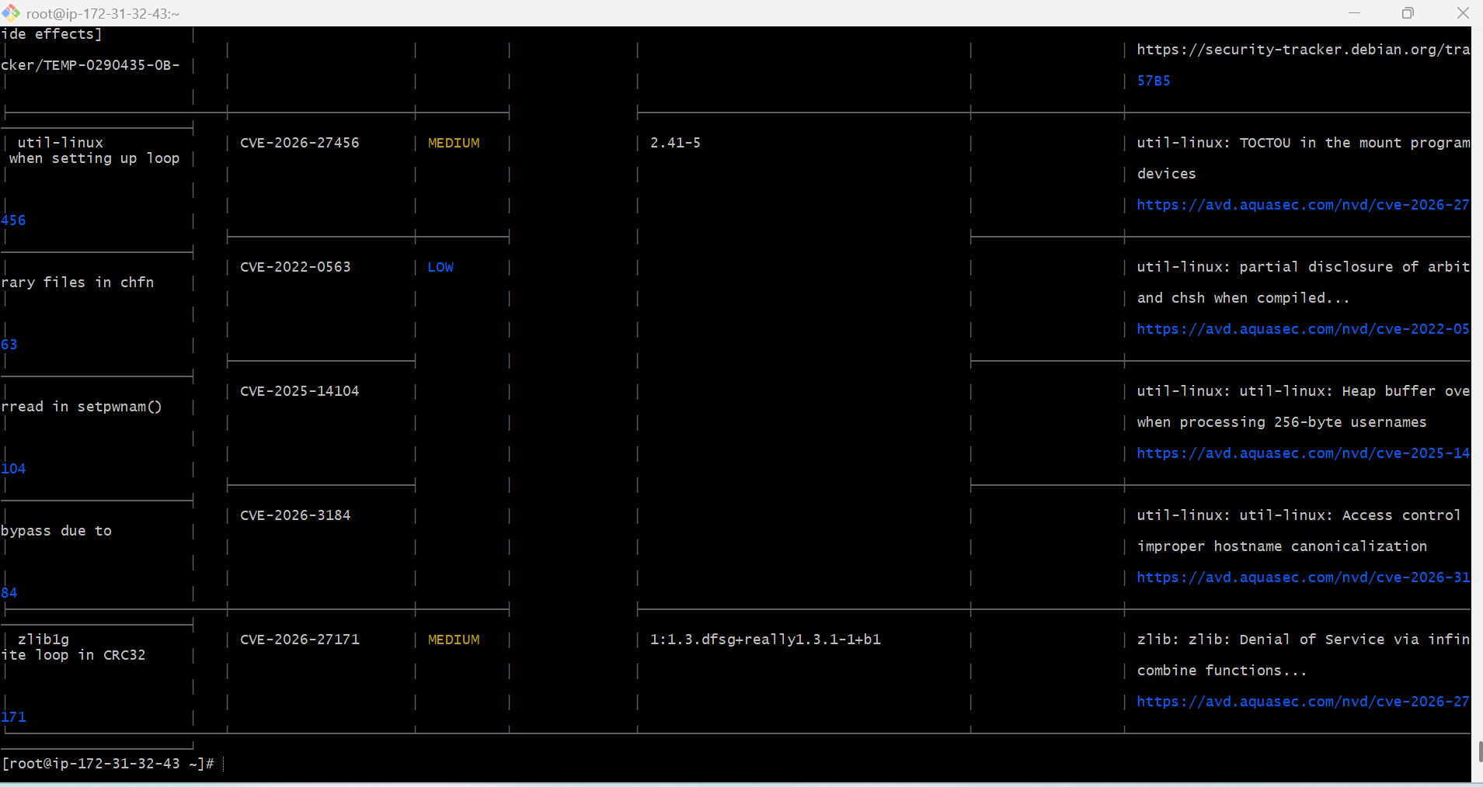

- Implement solution to scan images when pushed to AWS ECR.
- Create ECR Repository with Scanning
aws ecr create-repository \
--repository-name myrepo \
--region eu-north-1 \
--image-scanning-configuration scanOnPush=true
- Login to ECR
aws ecr get-login-password --region eu-north-1 \
| docker login --username AWS --password-stdin <account-id>.dkr.ecr.eu-north-1.amazonaws.com
- Tag Image
docker tag myapp:latest <account-id>.dkr.ecr.eu-north-1.amazonaws.com/myrepo:latest
- Push Image
docker push <account-id>.dkr.ecr.eu-north-1.amazonaws.com/myrepo:latest
- Check Scan Results
Go to:
AWS Console → ECR
Open repository → Images
Click image → Scan results tab
What you’ll see
CRITICAL
HIGH
MEDIUM / LOW
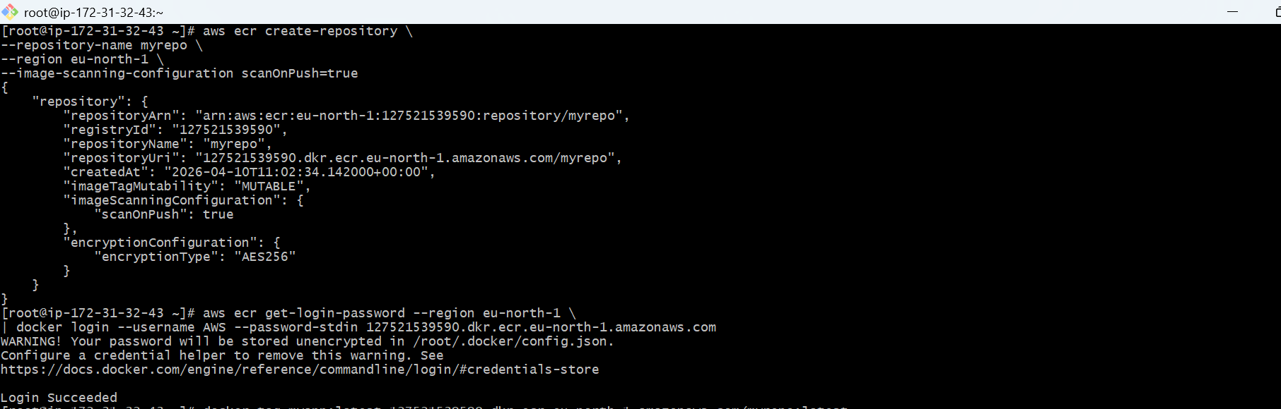
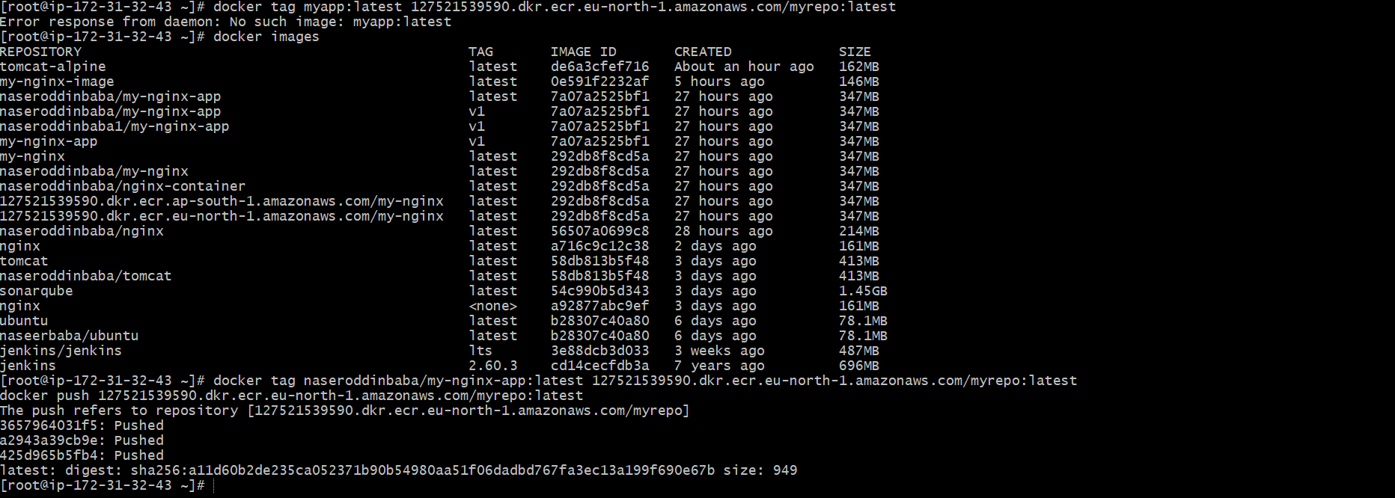

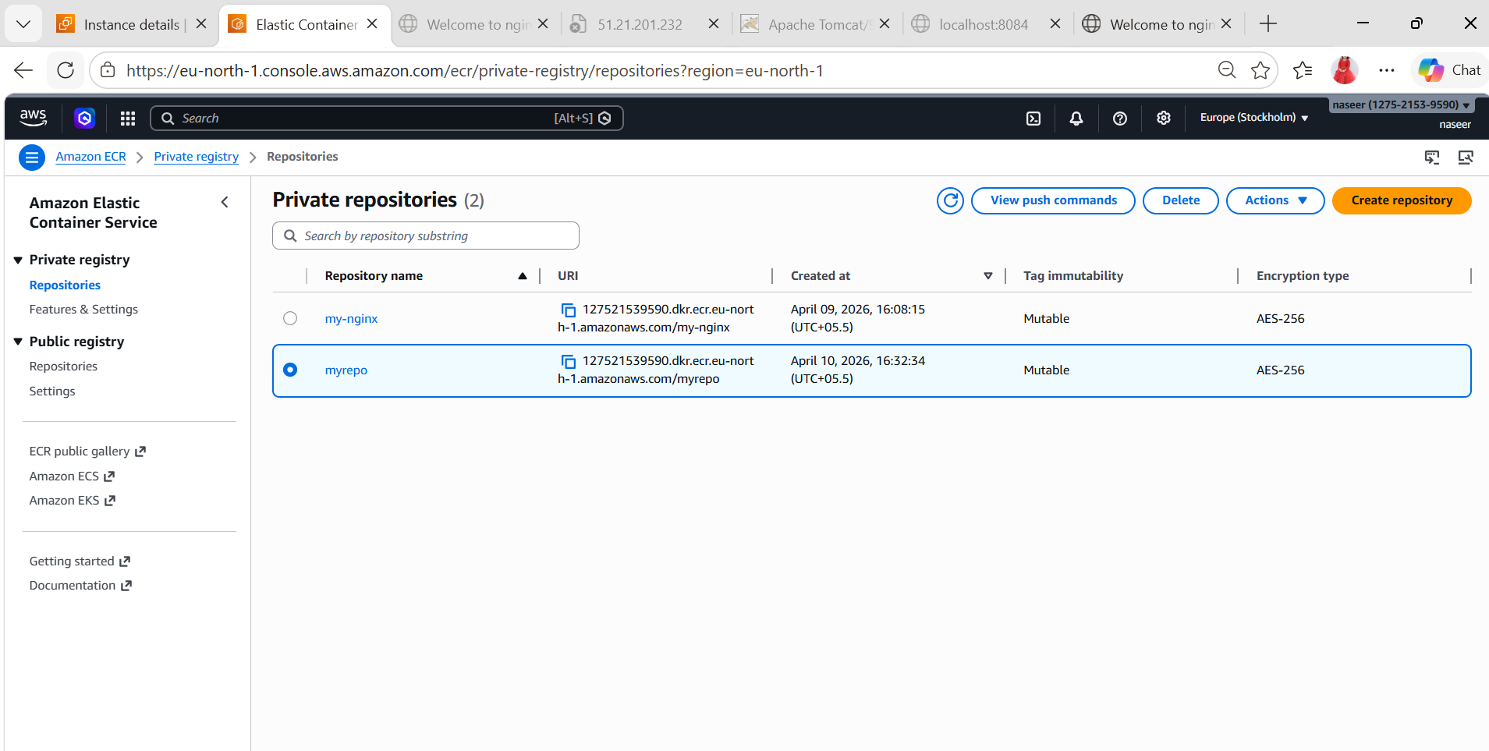
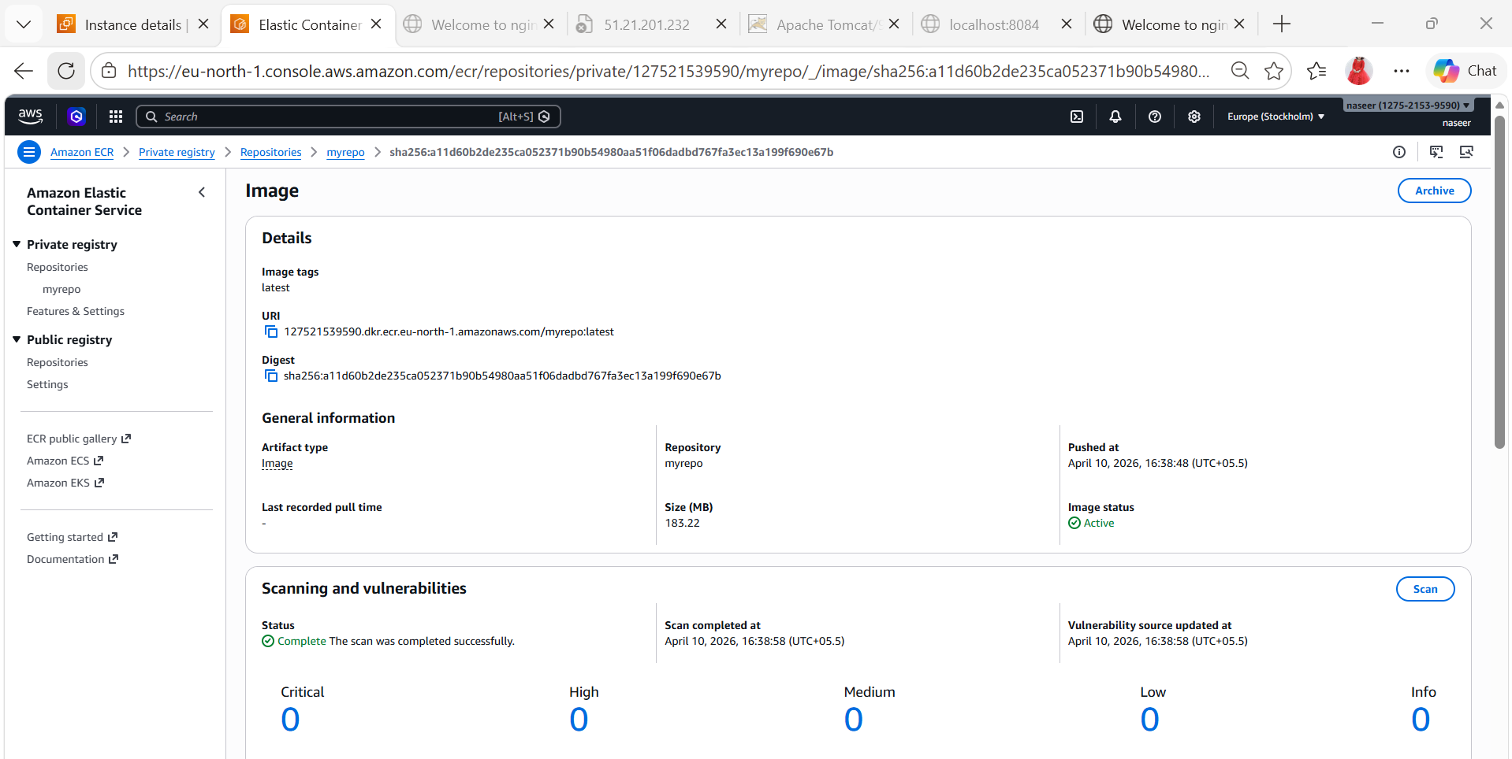

- Create a Jenkins pipeline to create a docker image and push the image to Docker hub.
- Add DockerHub Credentials in Jenkins
Go to Jenkins → Manage Jenkins → Credentials → Global → Add
Username: naseerbaba
Password: **********
ID: docker-hub
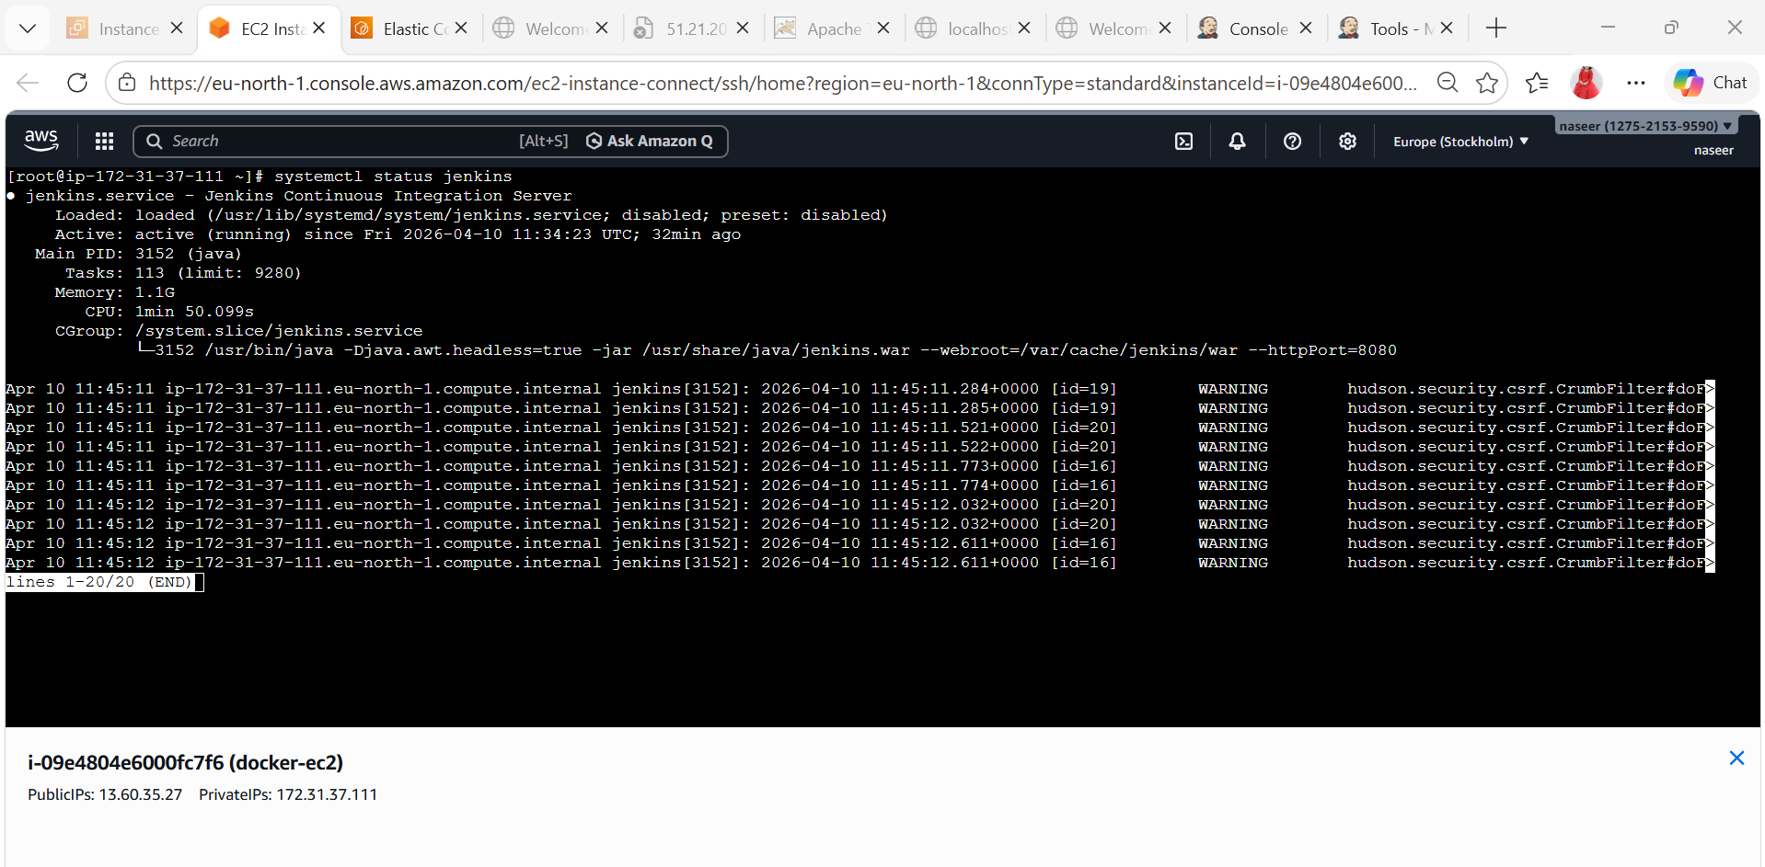
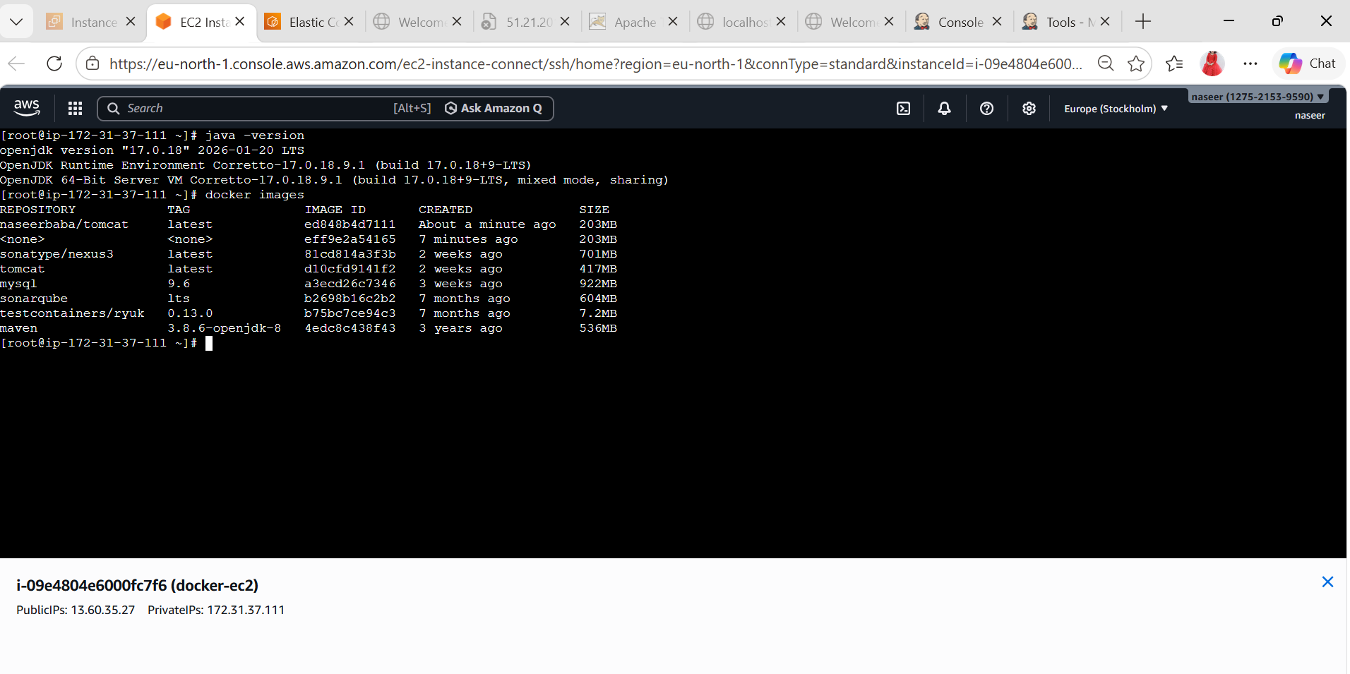
Create New Job
1. Click New Item
2. Enter name: Jenkins-dockerpipeline
3. Select Pipeline
4. Click OK
pipeline {
agent any
environment {
IMAGE_NAME = "naseerbaba/tomcat"
IMAGE_TAG = "latest"
}
stages {
stage('Clone Code') {
steps {
git 'https://github.com/betawins/multi-stage-example.git'
}
}
stage('Update Dockerfile for Java 17') {
steps {
sh '''
cat > Dockerfile <<'EOF'
FROM eclipse-temurin:17-jdk-alpine AS builder
WORKDIR /app
COPY . .
RUN chmod +x mvnw && ./mvnw clean package -DskipTests
FROM eclipse-temurin:17-jre-alpine
WORKDIR /app
COPY --from=builder /app/target/*.jar app.jar
EXPOSE 8080
ENTRYPOINT ["java","-jar","app.jar"]
EOF
cat Dockerfile
'''
}
}
stage('Build Docker Image') {
steps {
sh 'docker build -t ${IMAGE_NAME}:${IMAGE_TAG} .'
}
}
stage('Login to DockerHub') {
steps {
withCredentials([usernamePassword(
credentialsId: 'docker-hub',
usernameVariable: 'DOCKER_USER',
passwordVariable: 'DOCKER_PASS'
)]) {
sh 'echo ${DOCKER_PASS} | docker login -u ${DOCKER_USER} --password-stdin'
}
}
}
stage('Push Image') {
steps {
sh 'docker push ${IMAGE_NAME}:${IMAGE_TAG}'
}
}
}
post {
success {
echo 'Docker image built and pushed successfully'
}
failure {
echo 'Pipeline failed'
}
}
}
